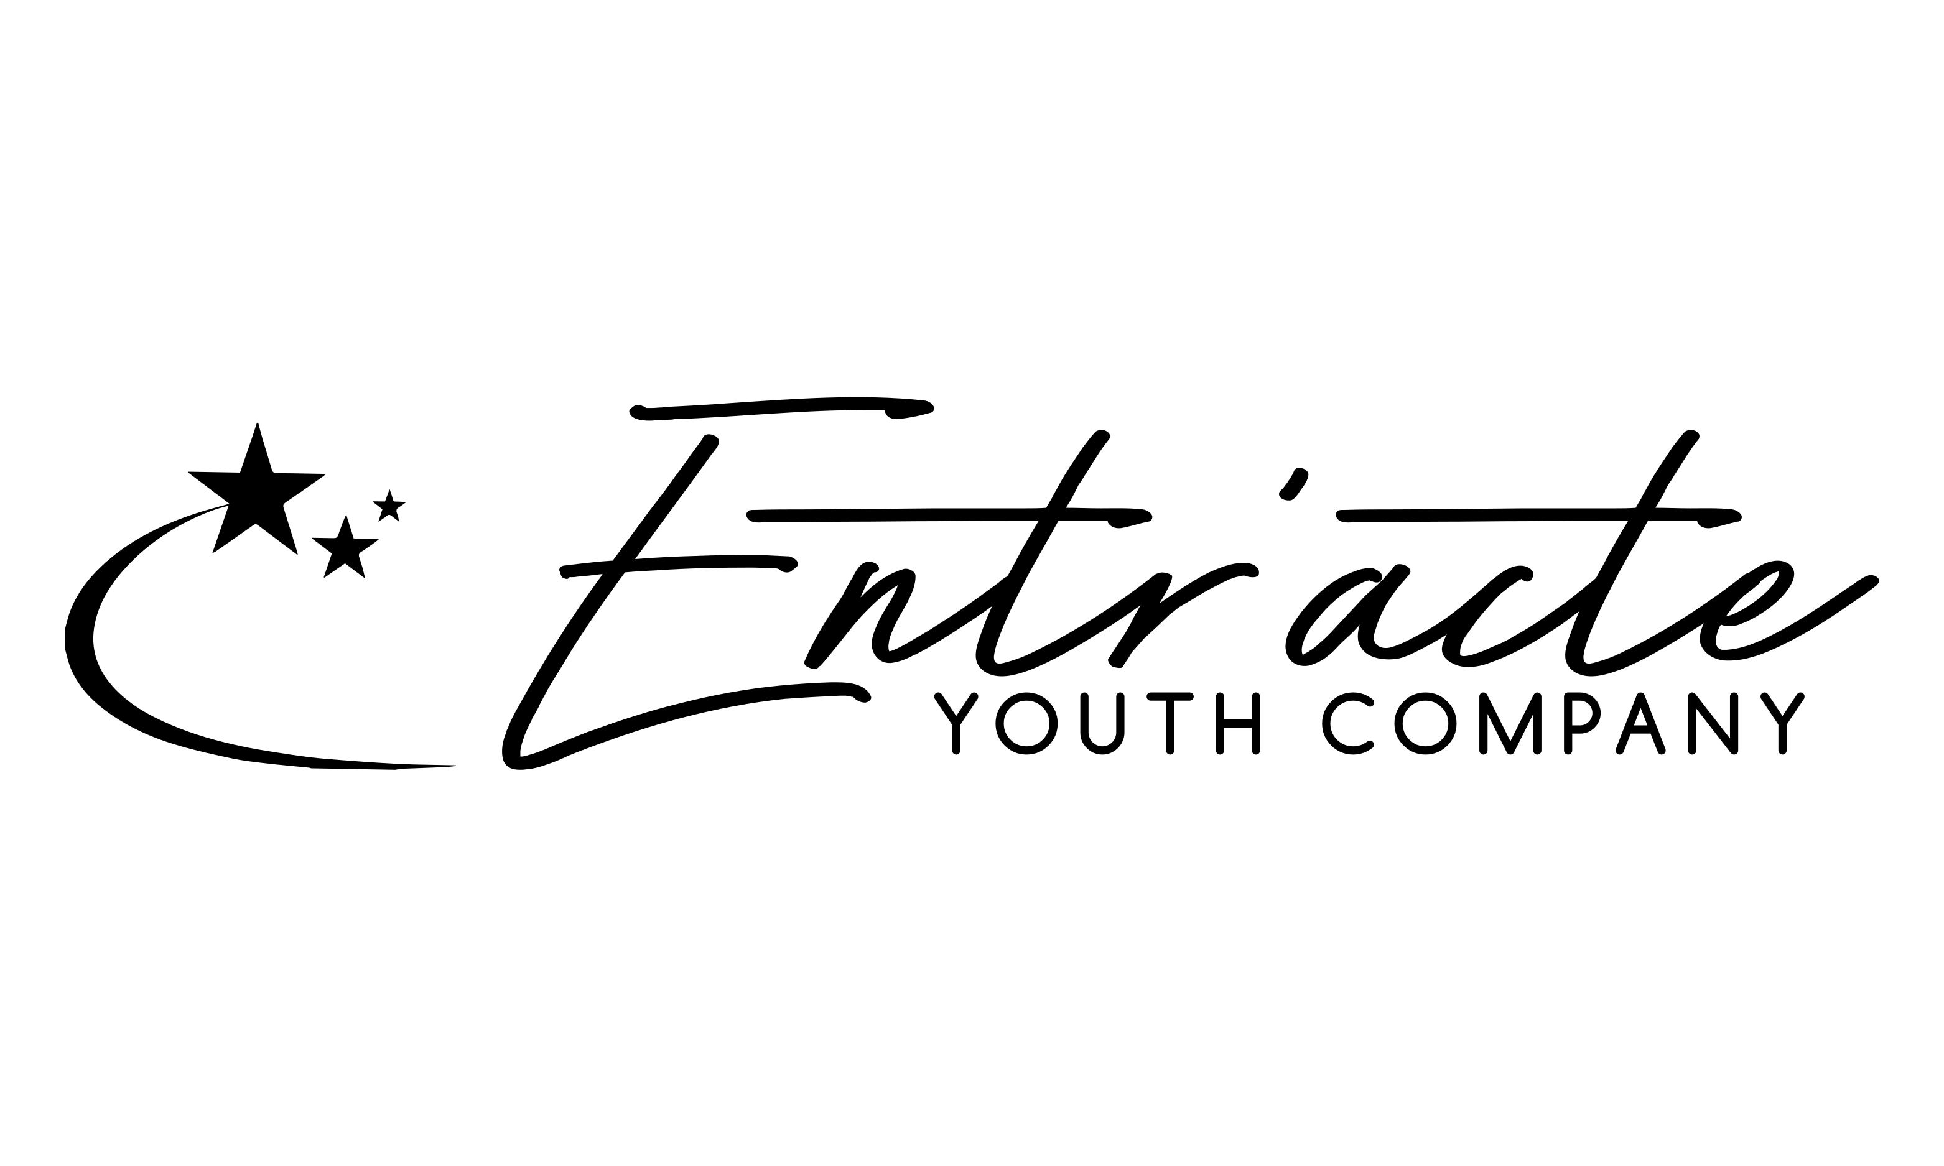

**Equality, Diversity and Equal Opportunities Policy**

**1. Statement of Policy**

Entr’acte Youth Company actively opposes all forms of unlawful and unfair discrimination and is committed to equality and inclusion at all levels of the organisation.

Entr’acte values the role diversity plays in encouraging a positive creative and working environment.  
We aim to ensure equality of opportunity in all activities. We strive to ensure that our policies and practices continue to be lawful, fair and actively inclusive.

**2. Organisation Responsibilities in law**  
Legislation requires organisations both to avoid discrimination and to promote equality for members, staff and audience members.

Our policy applies to the treatment of all the Entr’acte Youth Company members and staff.

Protected Characteristics:

* Gender
* Age
* Race
* Disability
* Sexual orientation
* Religion or belief
* Gender reassignment
* Pregnancy or maternity

**3. Responsibility**The company board hold the responsibility for upholding this policy.

They are responsible for overseeing the execution of the Equality and Diversity policy in all areas of Entr’acte Youth Company’s work.  
Any staff member, guest workshop leader or production team member are responsible for upholding the policies during their work for the company.

**4.** **Promoting Equality**  
We are committed to promoting:

* the uniqueness of the individual member
* the artistic development of all members in Entr’acte - we have the duty to care for all, and strive to ensure that we provide for those who are socially, academically, physically or emotionally disadvantaged.
* Preventing occurrences of any unlawful direct and indirect discrimination, harassment and victimisation (the four kinds of unlawful behaviour stated in The Equality Act 2010)
* Entr’acte ensure that all workshops and performance opportunities are available to disabled people by using premises that are accessible
* Fulfilling all our legal obligations under the equality legislation, including the Equality Act 2010, and all associated codes of practice.
* Complying with our own equal opportunities policy
* Publicity materials, publications, advertisements, events, workshops and performances shall avoid language which presents a stereotyped, offensive or detrimental view of any group or individual’s background on any of the above grounds. However, performances and workshops that include material from musicals/plays may present such language and views when the context of use is clear.

Consequently, we will strive to ensure that:

* any person recruited to the service of the youth theatre is made fully aware of our aims and objectives and will be required to support them;
* members who join Entr’acte are fully aware of our aims and objectives and undertake to support them;
* all of our structures and policies are evaluated and kept under constant review in order to see that no individual is subject in any way to unlawful discrimination, whether intentional or unintentional, and to ensure that all are enabled to reach their full potential.

**5. Changes to this notice**

Regular monitoring of Entr’acte Youth Company’s services and participants takes place to ensure that the equal opportunities policy is implemented and effective.

We keep this policy under regular review and we will place any updates on our website.

We encourage members and their parents to check this page for any changes and acknowledge and agree that is it you personal responsibility to review this policy periodically and become aware of any modifications.

This policy was last updated in March 2023.